Imagine if all Christians, as a normal part of their discipleship, were caught up in a web of regular Bible reading—not only digging into the Word privately, but reading it with their children before bed, with their spouse over breakfast, with a non-Christian colleague at work once a week over lunch, with a new Christian for follow-up once a fortnight for mutual encouragement, with a mature Christian friend once a month for mutual encouragement.
It would be a chaotic web of personal relationships, prayer, and Bible reading—more of a movement than a program—but at another level it would be profoundly simple and within reach of all.
It’s an exciting thought!
Colin Marshall and Tony Payne, The Trellis and the Vine

How to begin
First, pray. (Ask God: who should I do it with? What should we be reading? How long for?)
Second, invite. Approach the person you want to do this with
- Less frightening for them than being invited to a meeting where there will be lots of people they don’t know already, and a speaker they can’t interrupt!

- Make sure the expectations are clear and agreed between you. (How often will you meet? How long for? How can your friend bail out? What are your objectives?)
Third, meet. (But first, block out the agreed time slot for a considerable way ahead! You don’t want to have to chop and change unexpectedly – that destroys continuity!)

Pros and cons of preparation
Should you prepare for each session, or just open the Bible and see what happens?
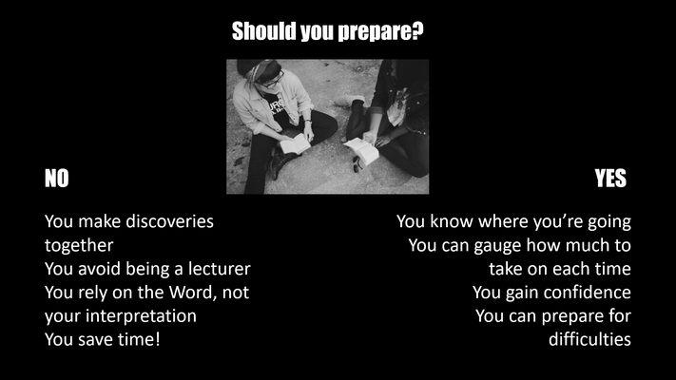

Preparing a session without using pre-printed materials: three steps…
- READ the passage carefully several times. Try different versions. Get a good feel for the shape of the passage, and try to spot any likely difficult bits.

- CHECK the context. Who wrote this? What were their intentions? What’s happening in the background? What might need explanation because it isn’t obvious at first reading? Find answers from good Internet resources (see the last part of these notes).

- WRAP UP the “gifts” you want to give – the discoveries you want your friend to make – in good questions which they can unwrap to find the answers themselves. Avoid “closed”, yes-or-no questions; make them do some thinking!

How to study any passage: observe, interpret, apply
Your study should help to answer three questions:
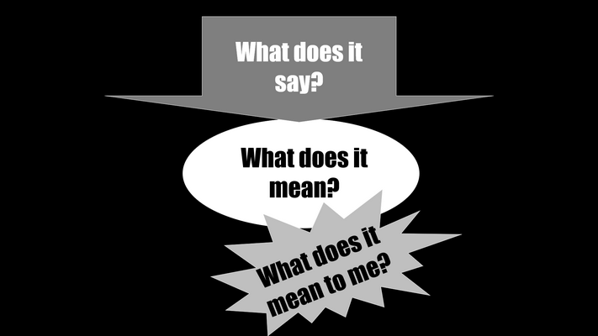
Don’t worry if it takes a few meetings before you settle into an easy, confident reading relationship with one another. Focus on becoming friends too. Share what’s going on in your own life, and build a relationship in which the other person feels it’s possible to ask any question, however stupid it may be, because you won’t laugh or judge or be impatient.
And just trust God’s Holy Spirit from there, to take it where he wants it to go!

But you don’t have to do it alone. Materials you could use:
One approach which gives you lots of help is “You, Me and the Bible” (https://www.thegoodbook.co.uk/you-me-and-the-bible ): six one-to-one Bible studies introducing people to the key ideas of Scripture, with notes for leaders and helpful video clips which you can play (even on your phone!) to summarize each session. Materials are cheap but if you have no money everything can be downloaded for free. See also http://www.matthiasmedia.com/ymb/ where you’ll also find some fun video clips you can download to show your friend in advance, so that they can see what you’re talking about before they agree to do it!
One approach which gives you less help, but lots of freedom, is the one described in David Helm’s online training course at http://www.reading121.org/ , which includes videos, FAQs, group activities, and downloadable sheets. Helm gives you questions you can use to prepare any passage of the Bible for one-to-one study, and an eight-session way of going through Mark’s Gospel, in a document at http://www.reading121.org/media/One-to-One-Reading-Sheets.pdf . And even if you decide not to use his material on Mark, the training course sessions are well worth watching! You’ll learn a lot.
One approach which gives you everything in one is “The Word one-to-one”, a tried and tested guide to the Gospel of John evolved by St Helen’s Bishopsgate. You’ll find it on an excellent website at https://www.theword121.com/ . It consists of (up to) 38 sessions taking 25-40 minutes each, and there are no questions supplied so that you can unpack the meaning then discuss it together in any way which is appropriate to your friend. It’s described on video at https://tinyurl.com/word121vids . You can buy materials for as little as £7.99 – although if you don’t have the money you can also download the full-colour materials free, then print them out yourself.
More resources
To see a Powerpoint which contains all of this material and more, and introduces each of the three approaches mentioned above, go to https://www.slideshare.net and put “one to one bible reading” into the search box.
The people behind “The Word One to One” have produced stacks of videos which can help you understand it, and assess whether it’s the right approach for you:
Rico Tice introduces the approach at https://www.youtube.com/watch?v=hwmGmSDcKzA
Richard Cunningham on the importance of one to ones is at https://www.youtube.com/watch?v=y_9V6J44GGs

How to use The Word One to One is at https://www.youtube.com/watch?v=5g1StIYztiQ&t=6s . That’s a brief introduction from Richard Borgonon, who pioneered the method. But there’s also a full training course, with nearly three hours of teaching, at https://www.youtube.com/watch?v=uFugaNqyDxU . And if you really want to learn about one-to-one methods in depth, there are 22 short videos by Borgonon, with titles like “You are a pawn in the game”, “Letting the gospel do the work”, “What if people go off at a tangent or stop the studies?”, and much more.

