MARRIAGE COURSE REGISTRATION FORM – Autumn 2020

Names:
Titles | First Name(s) |  |  | Surname(s)
Address

Post Code |  | Contact phone number
Email

How did you hear about “The Marriage Course”?

How long have you been married/in a relationship?

Do you belong to a church? Yes/No |  |  | If so, which?
Cheque enclosed: Yes/No |  |  | Payment by BACS? Yes/No
By completing this form we indicate that we are happy to be contacted by email/phone about the forthcoming Marriage Course.
Please let us know if you need a LARGE PRINT version of the Course Manual.
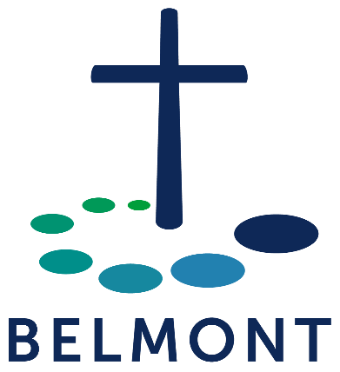
Please return this form, together with your cheque
for £45.00 (payable to “Belmont Chapel”)*
to:

Mike & Sue Cox
Belmont Chapel
Western Way
EXETER
EX1 2DB

*Payment may also be made by BACS using Sort code: 40 52 40 and Account number: 00020711. Please quote your name on the payment and email finance@belmontchapel.org.uk indicating that a payment has been made for the Marriage Course.
Charity No: 1184841

